电气工程学院 硕2102班 张晓红 21121535

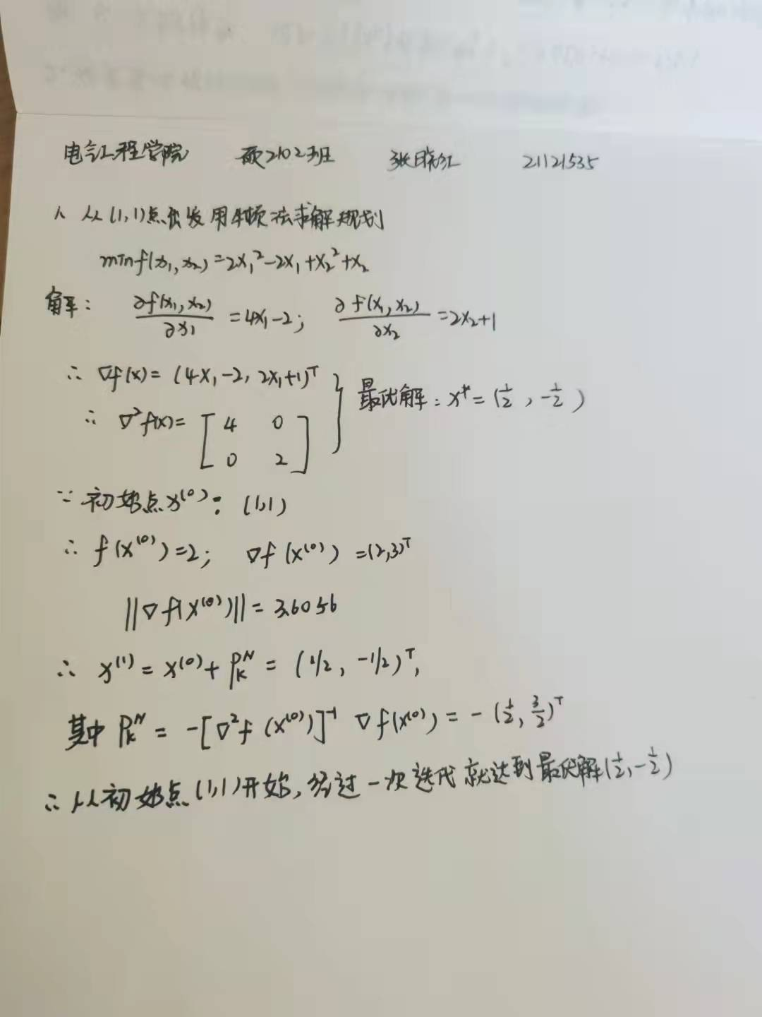

2. 代码（迭代4次）

function [xk,fk,k]=newton_method(x0,ess)

syms x1 x2 x3 x4;

x=[x1 x2 x3 x4];

A=[5 1 0 0.5;1 4 0.5 0;0 0.5 3 0;0.5 0 0 2];

f= 0.5 * x * x' + 0.25 * x * A * x' * x * A * x';

gf=[diff(f,x1),diff(f,x2),diff(f,x3),diff(f,x4)]';

Hess=hessian(f,[x1 x2 x3 x4]);

k=0; xk=x0';

fk=subs(f,[x1 x2 x3 x4],x0);

gk=subs(gf,[x1 x2 x3 x4],x0);

Hk=subs(Hess,[x1 x2 x3 x4],x0);

while((norm(gk)>ess)&&(k<4))

dk=-Hk\gk;

xk=xk+dk;

fk=subs(f,[x1 x2 x3 x4],xk');

gk=subs(gf,[x1 x2 x3 x4],xk');

Hk=subs(Hess,[x1 x2 x3 x4],xk');

k=k+1;

end

命令：

clear all;

x0=[1 1 1 1];

ess=1e-2;

[xk,fk,k]=newton_method(x0,ess);

k

xk=vpa(xk,5)

fk=vpa(fk,5)